**Java SE 21**

**and Java EE 7**

**Environment Setup Guide**

### **Part 1: Java SE 21 Setup**

#### **Step 1: Download and Install JDK 21**

1. **Visit the Official JDK 21 Download Page:**
   * Navigate to<https://jdk.java.net/21/>.

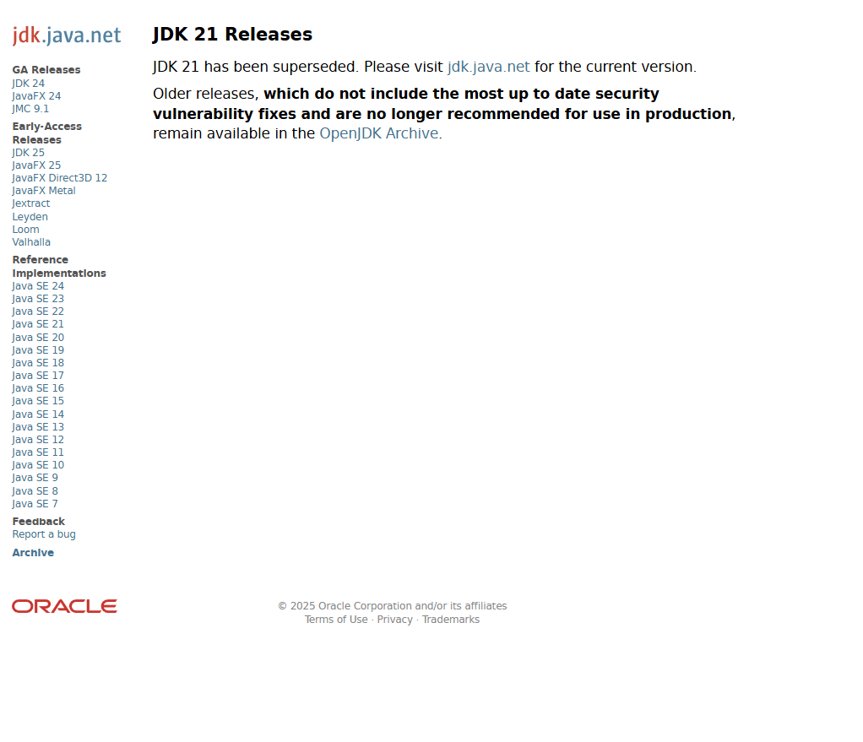

1. **Download the Installer:**
   * Choose the appropriate installer for your operating system (Windows/macOS/Linux).
2. **Run the Installer:**
   * Execute the downloaded installer and follow the on-screen instructions to complete the installation.

#### **Step 2: Set Environment Variables (Windows)**

1. **Access Environment Variables:**
   * Go to Control Panel > System > Advanced system settings > Environment Variables.
2. **Set JAVA\_HOME:**
   * Under "System variables," click "New" and set:  
     + **Variable name:** JAVA\_HOME
     + **Variable value:** Path to your JDK installation (e.g., C:\Program Files\Java\jdk-21)  
       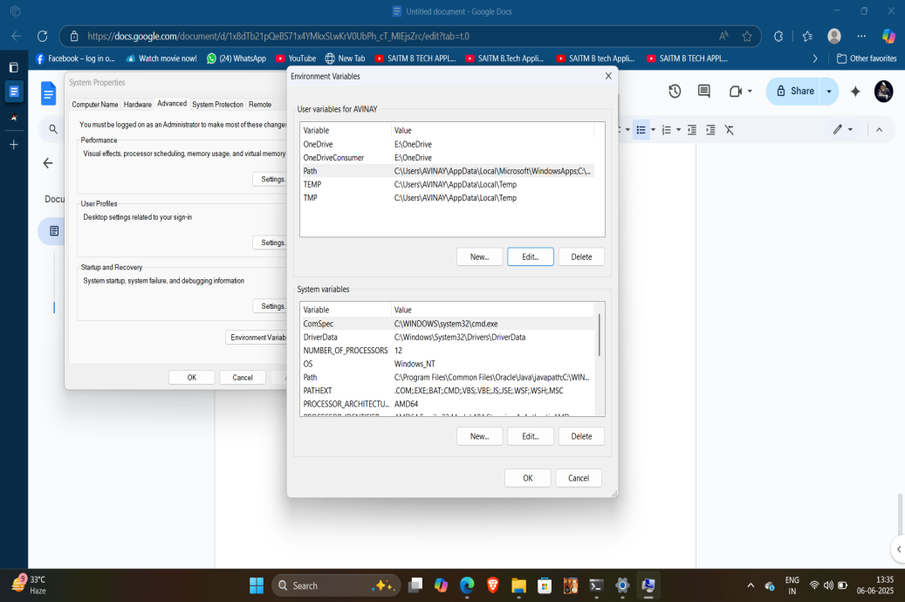
3. **Update PATH Variable:**Select the "Path" variable, click "Edit," and add %JAVA\_HOME%\bin.  
   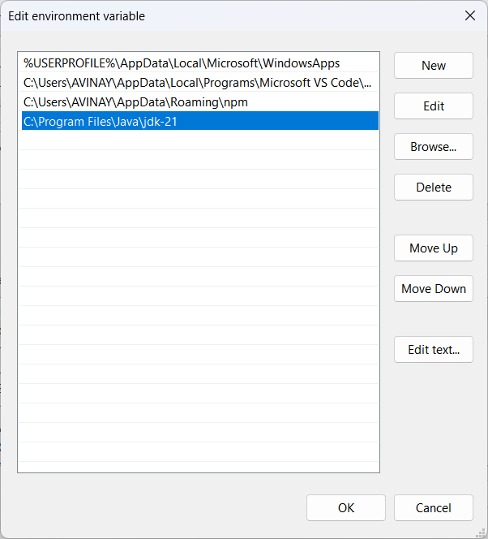

**IDE installation**

Eclipse IDE Environment Setup for Java SE 21 & Java EE 7

### Step 1: Download and Install Eclipse IDE

1. **Visit the Eclipse Downloads Page:**

Navigate to the official Eclipse downloads page: [https://www.eclipse.org/downloads/](https://www.eclipse.org/downloads/" \t "_new)

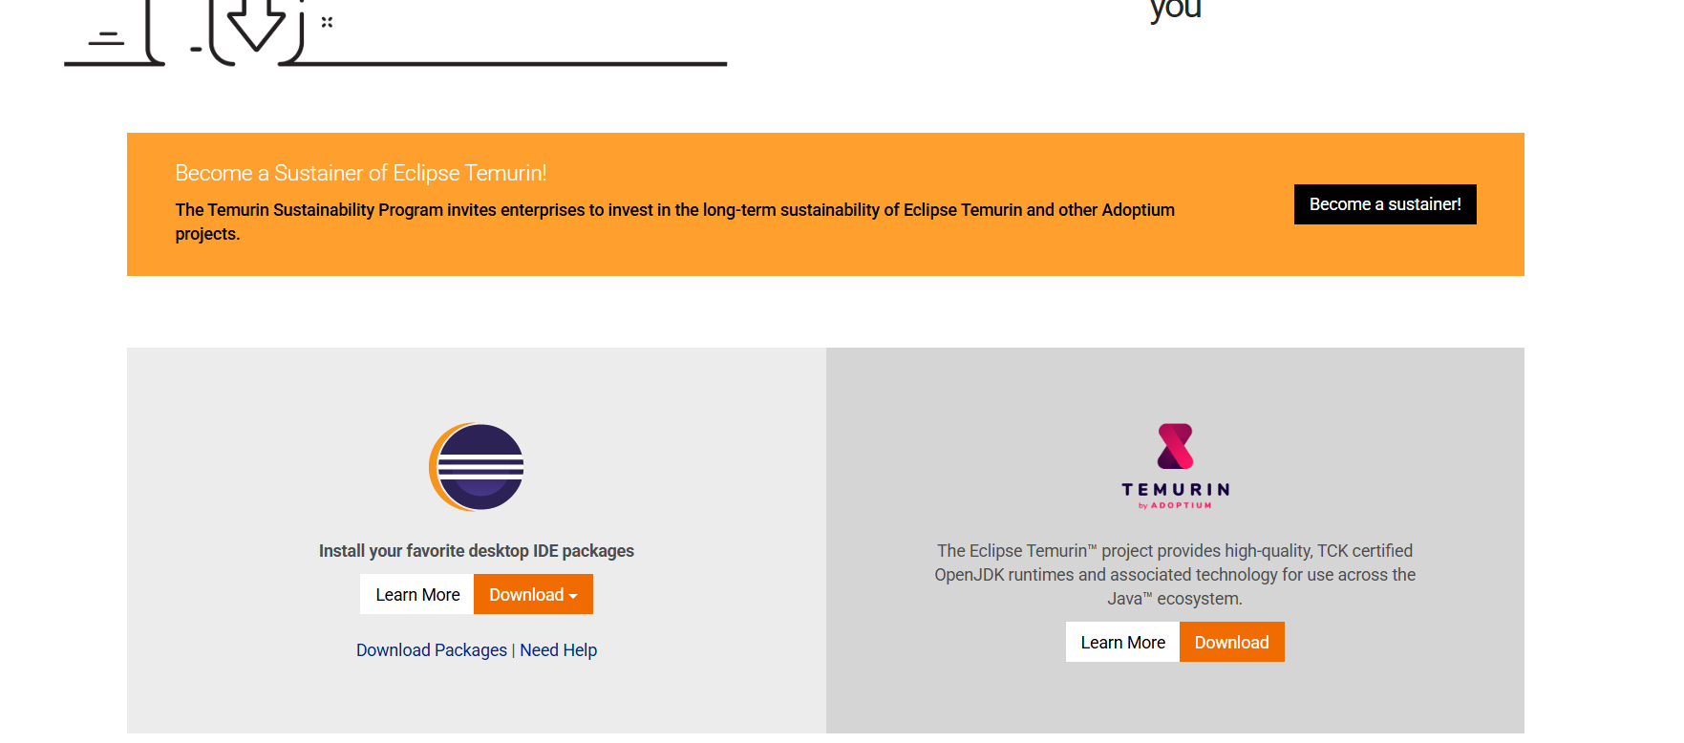

**Download the Eclipse Installer:**

Click on the "Download 64 bit" button to download the Eclipse Installer suitable for your operating system.

· **Run the Installer:**

After downloading, run the installer.[eclipse.org](https://www.eclipse.org/downloads/packages/installer?utm_source=chatgpt.com" \t "_blank)

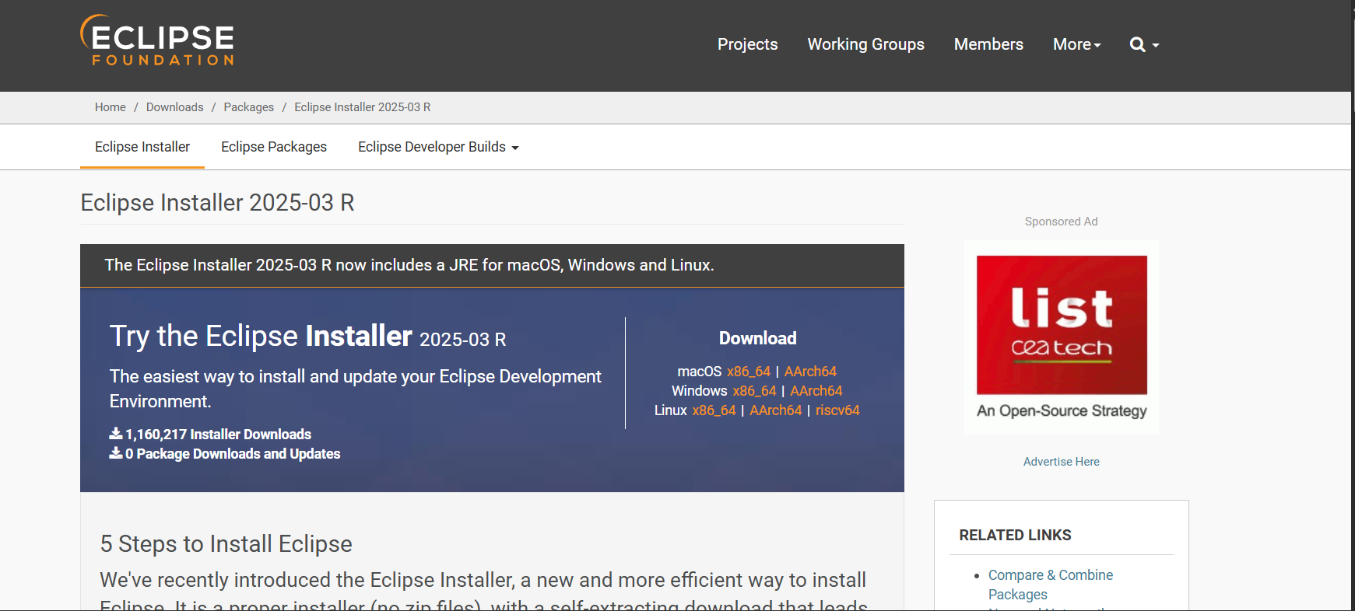

1. **Select Eclipse IDE for Enterprise Java and Web Developers:**

In the installer, choose "Eclipse IDE for Enterprise Java and Web Developers" to get the necessary tools for Java EE development.

1. **Choose Installation Folder:**

Select the directory where you want Eclipse to be installed

1. **Launch Eclipse:**

Once the installation is complete, launch Eclipse.